BRIDGE DETAIL FOR PAVING PROJECT

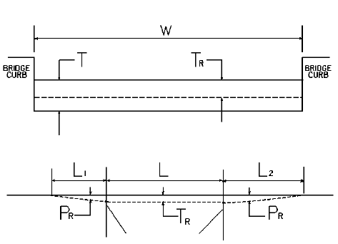

W = bridge width curb to curb
T = thickness of existing asphalt overlay
L = length of bridge
L₁ & L₂ = length of approach pavement to be removed
T_{R} = thickness to be removed and replaced on bridge
P_{R} = thickness to be removed and replaced on pavement
Note: L₁ & L₂ lengths shall be determined by using a transition rate of 100 ft/in of thickness

Route | Bridge No. | MP | W (ft) | T (in) | L₁ (ft) | L₂ (ft) | T_{R} (in) | L (ft) | P_{R} (in)

